MUSHROOM AND Budding YEAST ACTIVITY

Purpose: To observe the structure of various mushroom cells and observe the stages of budding yeast.

Procedure:
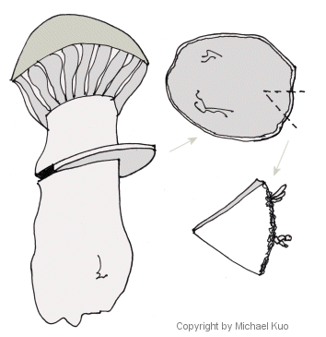
Use a compound microscope on medium power.
- Using a razor blade, shave off a thin layer of the mushroom stipe and crush it on the slide with the end of a blunt prob. Spread the edge of the stipe as thin as possible. Make a wet mount, view thinned edge of the stipe under medium power and draw what you see. In your simple biological drawing, but sure to label the stipe cells and include a title and reference.

- Using a razor blade, shave off a thin layer of the mushroom cap and crush it on the slide with the end of a blunt prob, and spread it thin. Spread the edge of the cap as thin as possible. Create a wet mount, view thinned edge of the cap under medium power and draw what you see. In your simple biological drawing, but sure to label the stipe cells and include a title and reference.

- Using a razor blade, carefully take one individual piece of the gill and view under medium or high power. The gill must lie flat on the slide as you are trying to view the basidia which line the bottom edge. Do NOT make a wet mount or use a cover slip and DON’T CRUSH THIS ONE. In your simple biological drawing, but sure to label the basidia and include a title and reference.

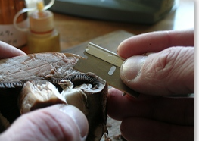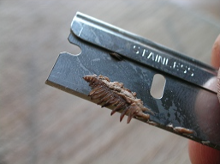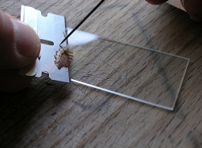

- Obtain a microslide viewer and the Asexual Reproduction booklet. Observe slide 2 “Budding – Yeast.” Draw a picture of the entire field of view labeling four different stages of budding. In your simple biological drawing, but sure to label the four stages (ie stage 1, stage 2, etc) and include a title and reference.

- Look at previously prepared slides of Ascomycetes (sac Fungi) called “Peziza”. Make a full biological drawing of what you see (include TM, observations, AS & DM). Be sure to label the ascus (sporangium) & ascospores (spores)

No conclusion is needed is needed for this lab. Submit your five drawings.

