Osmosis & Diffusion in an Egg | 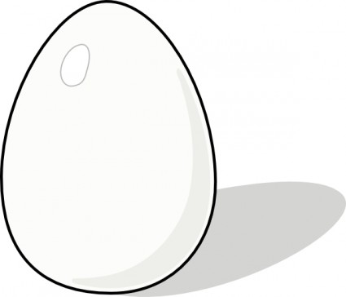
Objective: In this investigation, you will use a fresh hen's egg to determine what happens during osmosis & diffusion across membranes.

Report: Each student will submit a copy of the results, observations and their own answers to the discussion questions.

Materials (per lab group):
- 1 raw egg
- ruler
- string
- masking tape & marker
- distilled water
- clear sugar syrup (Karo, for example)
- vinegar
- 400 mL beaker
- paraffin wax
- tongs
- electronic scale
- weigh boat
- paper towels

Procedure:
Day 1:
- Using a string and ruler, measure the circumference of your egg (in mm). Record as “Original Circumference” (see back page).
- Label the beaker with your lab group name & the word "vinegar".
- After you zero the electronic scale, weigh the egg & record in Table 1.
- Carefully place the raw egg into the jar & cover the egg with vinegar.
- On the beaker, mark the vinegar level for reference of how much vinegar you added.
- Cover the beaker with paraffin wax & allow it to sit for 24 hours until the outer calcium shell (calcium carbonate – CaCO₃) is removed.
- Clean up your work area & put away all lab equipment.

After shell has dissolved (1-3 days):
- Observe the vinegar level in the beaker.
- Open the beaker & pour off the vinegar down the drain (flush with lots of water).
- Use tongs to carefully remove the egg to a paper towel & pat it dry.
- Using the same method as day 1, record the egg circumference & appearance in Table 1.
- Zero the scale, weigh the egg & record.
- Clean and re-label the beaker with your lab group & the word "distilled water".
- Carefully place the same egg into the jar & cover the egg with distilled water.
- On the beaker, mark the distilled water level for reference of how much distilled water you added.
- Cover the beaker with paraffin & allow it to sit for 24 hours.
- Clean up your work area & put away all lab equipment.

After 24 hours:
- Observe the distilled water level in the beaker
- Open the beaker & discard the distilled water.
- Use tongs to carefully remove the egg to a paper towel & pat it dry.
- Record the circumference & appearance of your egg in Table 1.
- Zero the scale, weigh the egg & record.
- Clean and re-label the beaker with your lab group’s name & the word "syrup".
- Carefully place the egg into the beaker & cover the egg with clear syrup.
- Cover the beaker with paraffin & allow it to sit for 24 hours.
- Clean up your work area & put away all lab equipment.

After another 24 hours:
- Observe the syrup level in the beaker.
- Open the beaker & pour off the syrup.
- Use tongs to very carefully remove the egg & rinse off the excess syrup under slow running water.
- Pat the egg dry on a paper towel.
- Record the circumference & appearance of your egg in your data table.
- Weigh the egg on the scale & record.
- Clean up your work area & put away all lab equipment.

Results:
Original Circumference of egg: ______________________

Table 1: Osmosis and Diffusion results with a hen’s egg placed in various solutions.
 | Original Mass (g) | Final Mass (g) | Appearance | Circumference (mm)
Vinegar
Water
Syrup

Questions & Conclusion: (Answer in complete sentences on a separate piece of paper)

1. Vinegar is made of acetic acid & water. Explain how it was able to remove the calcium shell.

2. (a) What happened to the circumference of the egg after remaining in vinegar?
(b) Was there more or less liquid left in the jar?
(c) Did water move into or out of the egg? Why?

3. (a) What happened to the circumference of the egg after remaining in distilled water?
(b) Was there more or less liquid left in the jar?
(c) Did water move into or out of the egg? Why?

4. (a) What happened to the circumference of the egg after remaining in syrup?
(b) Was there more or less liquid left in the jar?
(c) Did water move into or out of the egg? Why?

5. Was the egg larger after remaining in water or vinegar? Why?

6. Why are fresh vegetables sprinkled with water at markets?

7. Roads are sometimes salted to melt ice. What does this salting do to the plants along roadsides & why?

