Chapter 9: Similar Polygons and Triangles Name:
Calculating Missing Sides in Similar Figures

Solving Proportions

Practice- solve for x in each proportion:

Finding Missing Sides

Similar figures are always a reduction of enlargement of each other, therefore the ratio of the corresponding sides is always the same.

What this means is that by using a proportion (), you can determine the lengths of all the sides in both figures.

These polygons are similar. Find the length of the four missing sides on the smaller polygon using proportions.
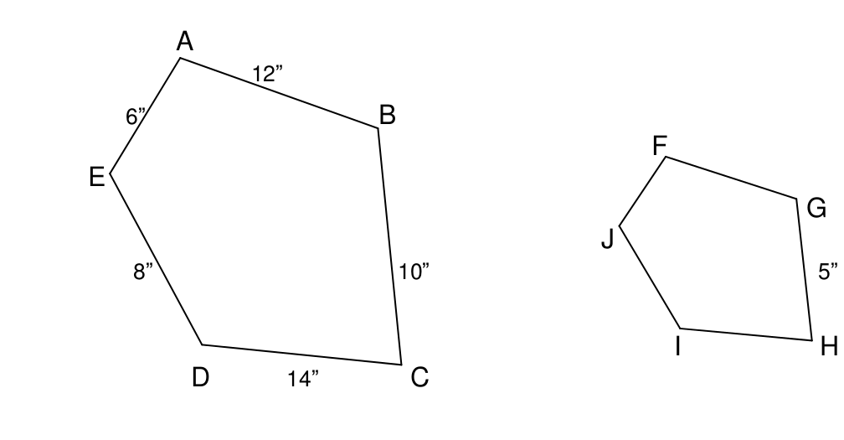
4”
Set up ratios of corresponding sides.

Keep same polygon in the same position in all ratios.
(eg. large on top, small on bottom)

Solve for missing side using cross multiply and divide

Are these triangles similar?
18.5 m
20 m
24 m
28 m
A
B
D
C
E

Name the pairs of corresponding sides and angles

Find the missing sides

Coordinates on a Graph

Points on a graph are identified by their coordinates. (x,y)
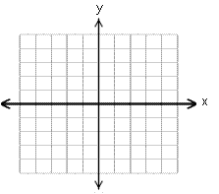
What are the coordinates of this triangle?

Are these triangles similar?


