Chapter 8: Relationships in Right Triangles Name:
Pythagorean Theorem

Triangles

- The angles in any triangle are always supplementary (add to 180º)
- A triangle is composed of three sides and three vertices (plural of vertex)
- To identify the side or vertex in a triangle, it is important to label the triangle following a standard routine:
Each vertex of a triangle is labelled with a capital letter
Each side is labelled with the lower case letter that matches the opposite vertex.

Practice: Finish labelling the triangles below

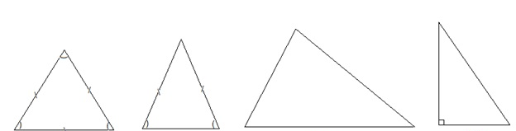
Types of Triangles

Equilateral Isosceles Scalene Right
Pythagorean Theorem

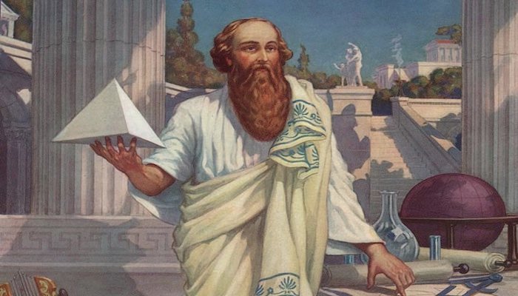
Pythagoreas was a Greek philosopher and mathematician.
Lived 570 – 495 BC

Pythagoream Theorem: States that the square of the hypotenuse is equal to the sum of the squares of the other two sides.

a² + b² = c²

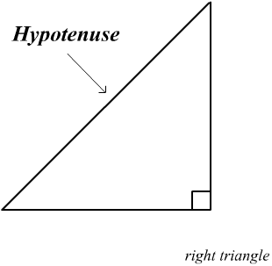
The side of the triangle that is opposite the 90º angle is always called the hypotenuse. It is labelled in the triangle below. The other two sides of the triangle are called legs.

To solve for the length of the hypotenuse:

9 m
12 m

Practice: Find the hypotenuse

20 ft
18 ft
125 cm
50 cm
30 mm
40 mm

The Pythagorean theorem can also be used to confirm if a triangle is a right triangle.

Is this a right triangle?

23 m
12 m

18 m

40 cm

40 cm

80 cm

A flagpole is 12 metres tall. It makes a shadow on the ground that is 15 metres long.
How long is a line that joins the top of the flagpole with the end of the shadow? Draw
a diagram and show your work.

