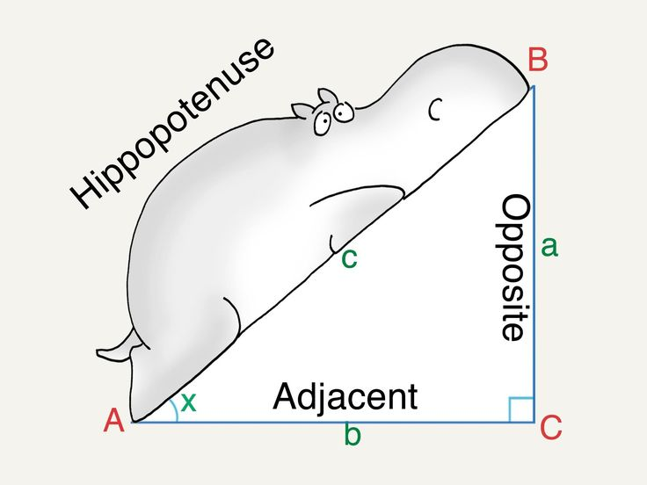
Chapter 8: Relationships in Right Triangles

Date | Topic | Assignment
Dec 4 | The Pythagorean Theorem | Pg 212-213 #2, 9, 10  Pg 216-217 #1, 3, 4, 5, 7
Dec 7 | Applying the Pythagorean Theorem | Pg 2220-221 #1-7
Dec 8 | Quiz 8A  Calculating Length: Sine Ratio | Pg 224 #1-5
Dec 9 | Calculating Length: Cosine Ratio | Pg 227 #1-3  Sine/Cosine Worksheet
Dec 10 | Calculating Length: Tangent Ratio | Pg 229 #1-3  Tangent Worksheet
Dec 11 | Calculating Angles: Trigonometry | Pg 231 # 1-3
Dec 14 | Quiz 8B  Solving Right Triangles | Pg 233-234 #1-7
Dec 15 | Review | Practice Test  pg 236-238 ALL
Dec 16 | Test
Dec 17 | Project/Rewrite Day | Chapter 8 Project Due!
Dec 18 | Christmas Party? Games Day? Christmas Skit!

At the end of this unit:

- I can use the Pythagorean theorem to calculate the missing side of a right triangle
- I know when to choose sine (sin), cosine (cos) or tangent(tan) based on the information given
- I can use the three basic trigonometric functions (sin, cos, tan) to find a missing side or angle of a right triangle
- I can determine the angle of elevation and the angle of depression for words or a diagram, and use them with the trigonometric ratios
- I can determine places in the workplace where I could us e trigonometry

Vocabulary:

adjacent
angle of depression
angle of elevation
cosine
hypotenuse
leg
opposite
Pythagorean Theorem
right triangle
sine
tangent
SOH CAH TOA

