Chapter 7: Lines and Angles Name:
Estimating, Measuring & Describing Angles

An angle is formed when two rays meet at a point called a vertex. Angles are measured in degrees (°), and can be measured with a protractor. There are 360° in a circle. A straight line is 180°.

Angles are classified as follows:

Acute angle – measure is between 0° and 90°
Right angle – measure is exactly 90°; the two rays are perpendicular to each other
Obtuse angle – measure is between 90°and 180°
Straight angle – measure is exactly 180°
Reflex angle – measure is between 180°and 360°
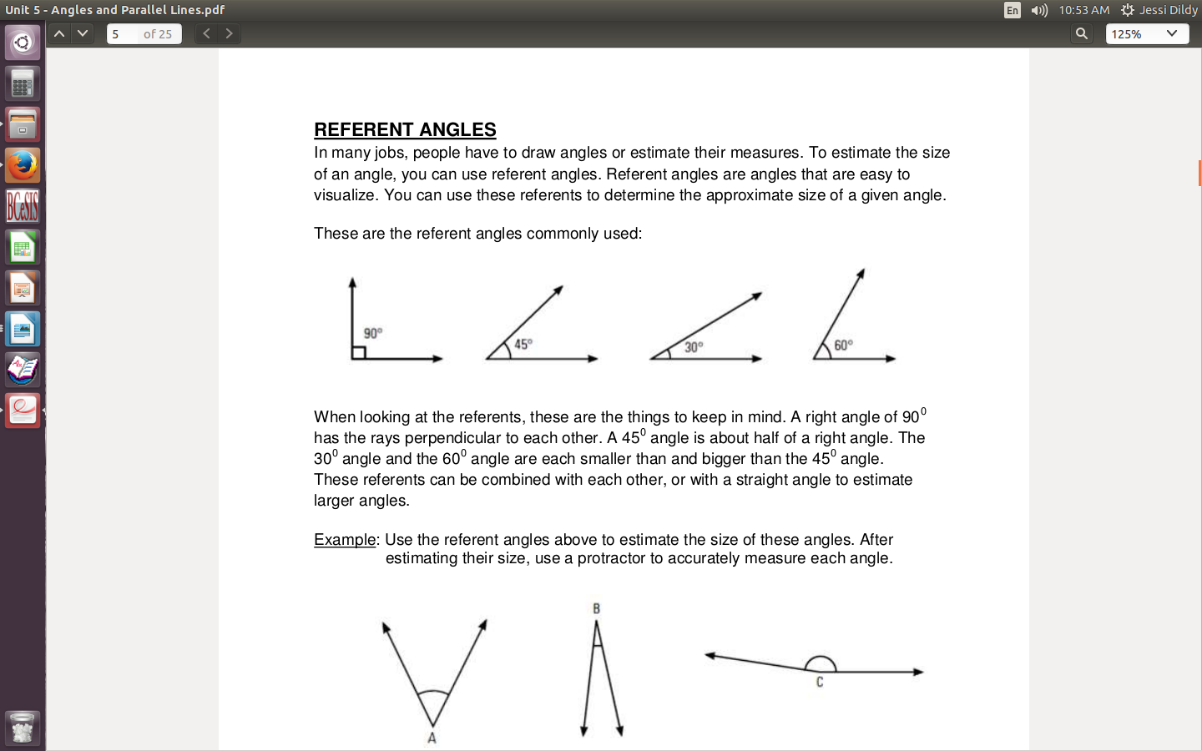
Estimating Angles:

Using a Protractor:
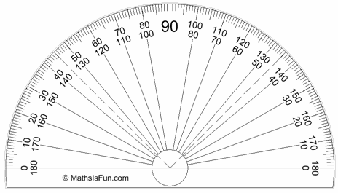
1. Align center point with vertex of angle

2. Line up the 0° on the bottom of the protractor with the bottom ray of the angle

3. Read the number the second ray passes through on the same scale as the 0°

Practice: Estimate, classify and measure each angle:

Estimate:__________________  Type: _____________________  Measure: __________________ | Estimate:___________________  Type: _____________________  Measure: __________________ | Estimate:___________________  Type: _____________________  Measure: __________________
Estimate:__________________  Type: _____________________  Measure: __________________ | Estimate:___________________  Type: _____________________  Measure: __________________ | Estimate:___________________  Type: _____________________  Measure: __________________

Naming Angles:

Angles are names using letters for each end of the rays and the vertex.

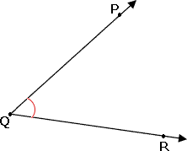
Ex.

Practice:

1. Draw a 50° angle and label it <DEF

2. Draw a 140° angle and label it <XYZ

Adjacent Angles – Angles that share a vertex and one common ray.

Supplementary Angles – Angles with a sum of 180°

Complementary Angles – Angles with a sum of 90°

Practice: Without using a protractor label the missing angles in each diagram:

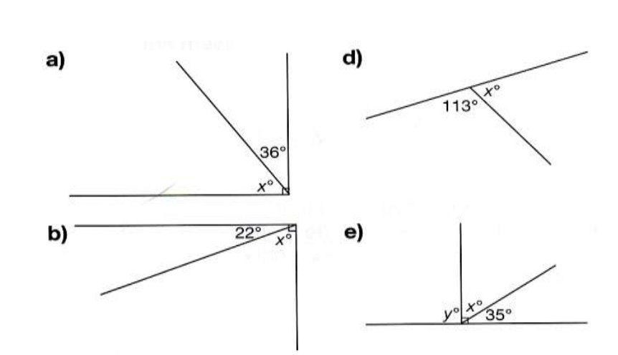

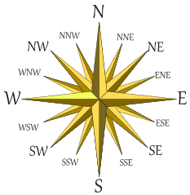

The compass rose is illustrated here. It shows many of the common bearings you might have heard of. You can see that east has a bearing of 90°, south has a bearing of 180°, and west has a bearing of 270° . In between each of these cardinal directions, the bearings are half of the 90°.

Each of the directions shown on this compass rose has a measure of _____________ .

Through addition and subtraction, all other bearings can be found.

Example: What is the true bearing of a boat heading southwest?

