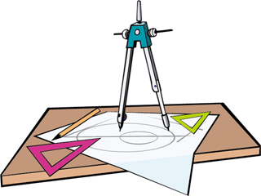
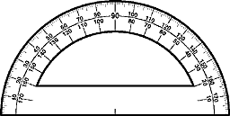
Chapter 7: Lines and Angles

Date | Topic | Assignment
Nov 23 | Estimating, Measuring & Describing Angles | Pg. 186-187 #1-5  Pg. 189 #1-4
Nov 24 | Quiz 7A  Bisecting Angles | Pg. 191 #1-4
Nov 25 | Replicating Angles | Pg. 193-194 #1-3  Pg. 195 #1-3
Nov 26 | Classifying Angles and Lines | Pg. 198 # 1, 3, 4, 8
Nov 27 | Grudge Ball | Lines and Angles Assignment  Due Nov 6
Nov 30 | Parallel Lines and Transversals | Pg. 202-203 #1-5
Nov 1 | Quiz 7B  Calculating Angles | Pg. 205-206 #1-4  Pg. 207 A-C
Nov 2 | Review | Pg 208-210 ALL  Ch 7: Practice Test
Nov 3 | Test

After completing this unit:
- I can measure, and describe angles of various measures
- I can draw to show the meaning the following types of angles: acute, right, obtuse, straight, reflex
- I can draw and copy angles using a compass and ruler
- I understand and can show the meaning of the terms complementary and supplementary angles
- I can bisect angles using a protractor, or using a compass and ruler
- I understand and can show the meaning of alternate interior angles, alternate exterior angles, corresponding angles, vertically opposite angles, interior and exterior angles on the same side of the transversal
- I can determine whether or not lines are parallel using angles and a transversal

Vocabulary:
angle
angle bisector
angle referent
acute angle
alternate exterior angles
alternate interior angles
complementary angles
corresponding angles
obtuse angle
parallel lines
perpendicular lines
reflex angle
right angle
straight angle
supplementary angles
transversal
vertically opposite angles

