Chapter 5: Capacity, Volume, Mass & Temperature Name:
Volume (Imperial)

The volume of an object is the amount of space it occupies. There are specific formulas
used to find the volume of different geometric solids. Just as area is expressed in square
units, volume is ALWAYS expressed in cubic units; (cm³, in³, m³, etc. )
In equations, the symbol for volume is a capital V.

1in³ = 1in x 1in x 1in

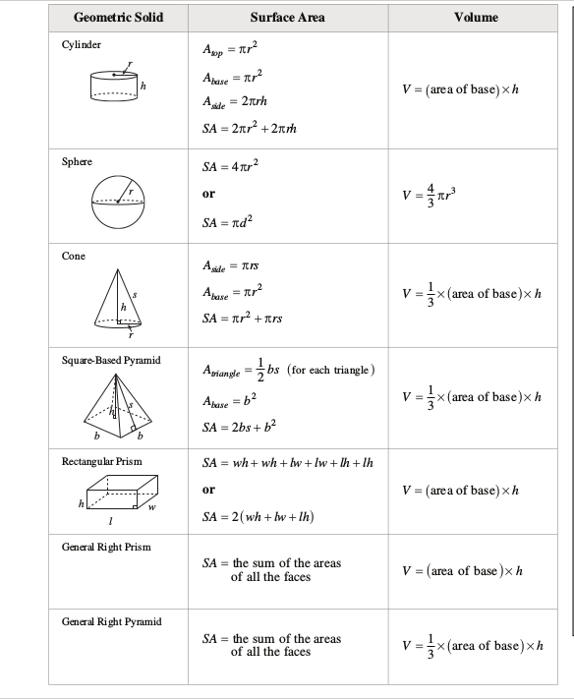

Practice: Calculate the Volume

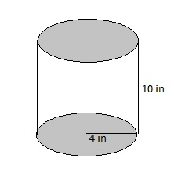

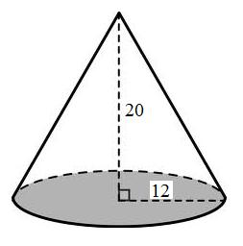

ft

ft

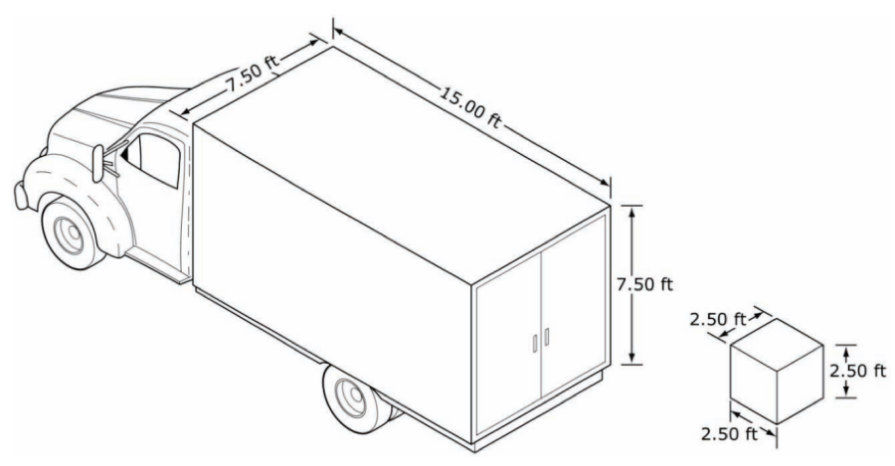

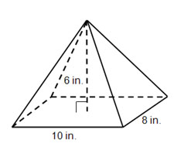

To convert between units of volume we must cube the conversion values for liner measures
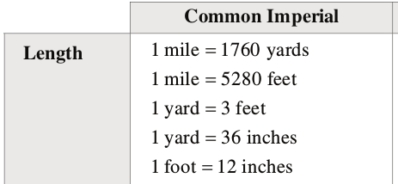

Example:

Convert 108 ft³ into cubic yards (yd³)

Linear Conversion: ______ ft = _____ yd

Cubed Volume Units: ______ ft³ = _____ yd³

Set up a proportion with equivalent fractions.

Match units in numerators and denominators

First Fraction:
values from data table/conversion
Second Fraction:
values from question (known/unknown)

Practice:

1. 3 mi³ = _________ yd³

2. 650 in³ = _________ ft³

3. 28 ft³ = _________ in³

4. 0.25 mi³ = _________ ft³

