Chapter 2 – Review

Imperial System

The imperial ruler uses fractions to divide an inch.

Fill in the measurements:

Practice:Measure the line

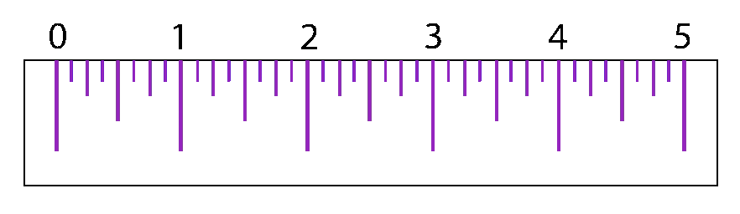
Length: ______________

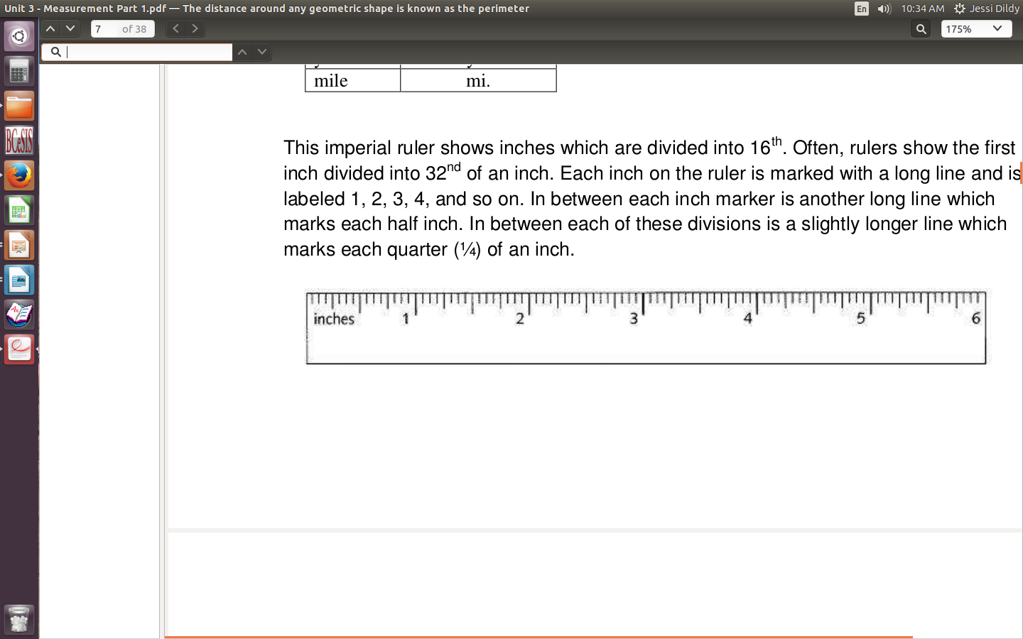

Length:_______________

Conversion between units in the Imperial System:

7 ft = ? in

6 yd 1 ft 4 in = ? in

19 1/2 mi = ? ft

17902 ft = ? mi

127 in = ? ft & in

Metric System

The metric system ruler is divided into 0.1cm (1mm)

Practice:Measure the line

Length:_____________
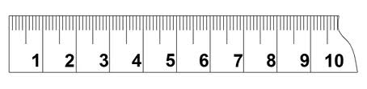

Length:_____________

Conversions between metric units

234 m = ? cm

3.98 cm = ? mm

98 dm = ? m

67.98 mm = ? m

Conversions between metric and imperial units

45 in = ? cm

234 cm = ? yd

24.6 mi = ? km

56 mm = ? in

4'3” = ? cm

Find the Midpoint

