Ch 2-3 Linear Measurement Name: Block:
Measurement Assignment 2: DESIGN YOUR DREAM ROOM

Your job is to create a floor plan for your dream bedroom. You will choose the size/shape of your room and sketch the size and location of the furniture you choose.

This room plan will be used as the basis for a future project.

□ 1. Draw the outline of your room on the graph paper provided.
- The scale of your drawing is 1 cm = 1 ft
- Use a ruler for all straight lines.
- Don't forget doors, windows and closet
- You may choose to include an en suite bathroom, balcony, sitting area, media room etc.
- Include at least one angled wall
- Be creative!

□ 2. Sketch the location of the furniture in your room.
- Pay attention to scale.
- You may wish to shop online for furniture to get an idea of size. (eg. Ikea, The Brick, Amazon)
- Include at least one circular object in your room design. (rug, table, etc)
- Google “floor plan symbols” or “floor plan furniture” to help you with your drawing
- Label each object with a name and its dimensions

□ 3. Record the dimensions and perimeter of the objects in your dream room on the chart attached.
- 1 cm on the drawing = 1 ft actual size
- Show sample calculations for at least one conversion from imperial to metric
- Show sample calculations for at least one calculation of circumference
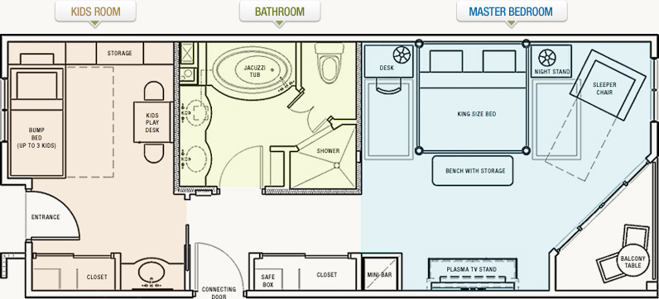
Assessment Rubric

 | 3 | 2 | 1 | 0
Floor Plan | Above and beyond requirements  Size and location of furniture/doors windows is unique and thoughtful.  All labels and measurements included | All requirements included.  Size and location of furniture/doors windows is well thought out.  All labels and measurements included | One required element missing.  Layout or sizes unrealistic or poorly not well thought out.  Some labels missing. | Missing or incomplete
Measurements & Calculations | All objects included on chart.  Units included on all dimensions  Calculations are clear and easy to follow.  All answers correct. | All objects included on chart.  Units included on most dimensions  Calculations are easy to follow.  Most answers correct. | Objects missing from chart  Units included on some dimensions  Calculations are difficult to follow.  Most answers correct. | Missing or incomplete
Creativity & Presentation | Very neat and professional.  Unique ideas and creative arrangement.  Work shows attention to detail and precision. | All lines are neat & drawn with a ruler.  Clearly labelled  Shows careful thought and creativity | Some sloppy lines.  Labels missing or incomplete.  Basic design. | Sloppy work.  Missing labels.  No thought put into design or layout.

Complete the following chart for your room(s) and all furniture and accessories
Object | Dimensions | Perimeter (imperial) | Perimeter (metric) | Sample Calculations

