Chapter 2-3 Linear Measurement: Name:
Converting Between Metric and Imperial Systems

It is important to be able to convert metric units to imperial units, and vice versa. Below are some of the common conversions available for units of length. Note that the sign “≈” means approximately. These conversions are not exact but are what will be used for this course. Online conversions calculators give more precise conversions if needed.
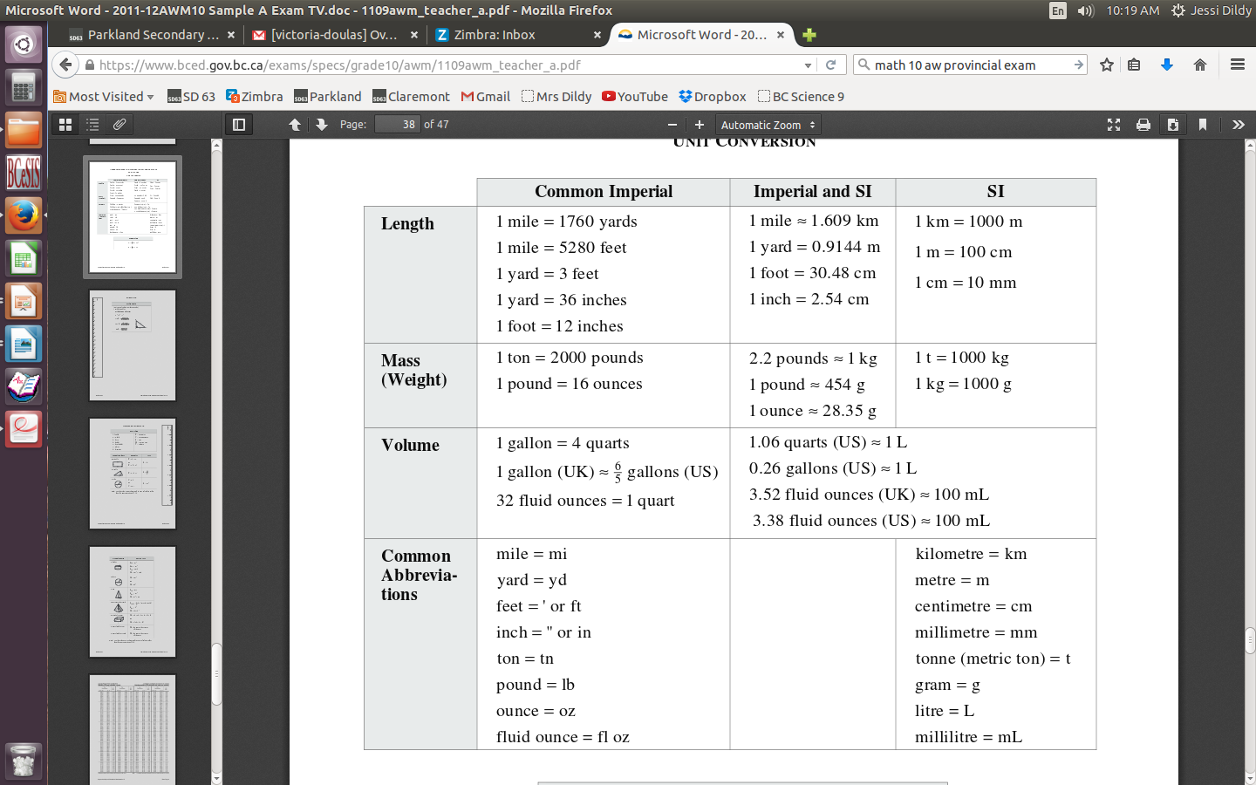

To convert between units (in any system) we will set up a proportion with equivalent fractions and solve for the unknown using “cross multiply and divide”

It may be necessary to perform this operation more than once to achieve the desired units.

Example:

1. How many inches are in 68 cm?

2. How many feet are there in 2 km?

3. Carla needs 3.5 m of cloth. However, the cloth she wants to buy costs $9.79 per yard.
How much will this cloth cost?

4. How many kilometres is a marathon which has a distance of 26 mi 385 yd?

Practice:
1. Convert each measurement:
a) 8 in = __________________ cm

b) 9.5 km = ________________ mi

c) 25 yd = __________________ m

d) 67 m = __________________ ft

e) 24 ft = __________________ cm

2. An airline has size limits for checked baggage. The length, width and height of alll
luggage must add up to no more than 157 cm. Will the airline accept a suitcase that
measures 17 in. by 26 in. by 14 in.?

