Ch 2-3 Linear Measurement Name:
Perimeter and Circumference

Formulas from Data Booklet:
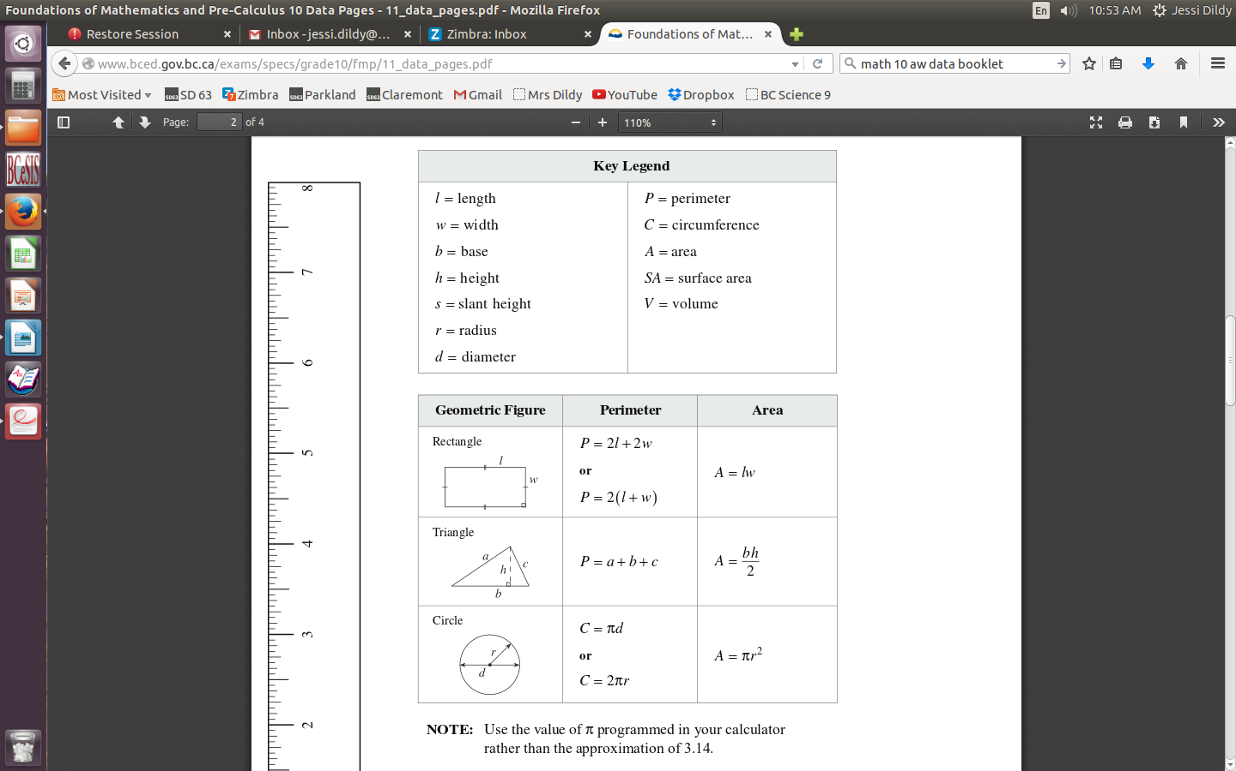

Perimeter

The distance around any geometric shape is known as the perimeter. To calculate the perimeter, simply add the lengths of all the sides together. Perimeter is always in linear units: cm, in, ft, m, etc.

Example: Find the perimeter
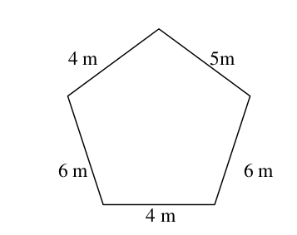

A rectangle has a special formula that can be used to calculate its perimeter. The perimeter is two of the length plus two of the width. It doesn’t matter which side is called the length and which one is called the width. In math terms, this means times the length plus two times the width.

P = 2l + 2w or P = 2(l + w)

Example: Find the perimeter

3 cm
8 cm
Practice:

1. Find the perimeter
4¾”
a)
2½”
2½”

2½”
2½”
4¾”

b)
20 m

12 m

16 m

36.8 cm
c)

8.4 cm

2. Chandra is building a fence around her swimming pool to completely surround it. The
pool is 25 feet long and 12 feet wide. There is a 6 ft walkway around the entire pool.
How much fencing will she need?

3. A rectangular playground space is 55 ft wide and required 190 ft of fencing to surround it. What is the length of the playground?

Circumference

The perimeter of a circle has a special name and formula as it is impossible to “measure” a circle’s sides. The special name for perimeter of a circle is the circumference.
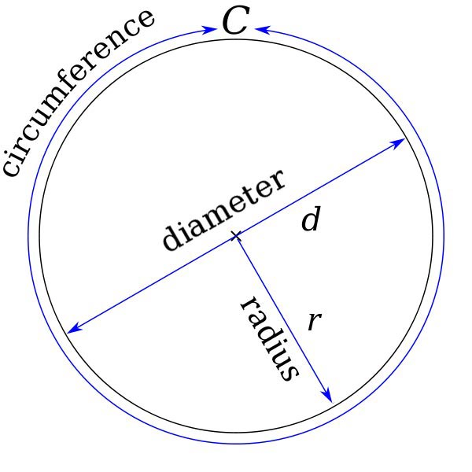

C = πd or C = 2πr

Example: Find the circumference
1.4 ft
38 mm

Rearranging Formulas

Sometimes it is necessary to solve for a different variable in a formula than the one given.

Isolate the desired variable from a formula by following these “rules”

RULE #1: you can add, subtract, multiply and divide by anything, as long as you do the same thing to both sides of the equals sign.

RULE #2: to move or cancel a quantity or variable on one side of the equation, perform the "opposite" operation with it on both sides of the equation.

Example: What is length of one spoke of a wheel with a circumference of 190 cm.

Practice:

1.
6 ¼”

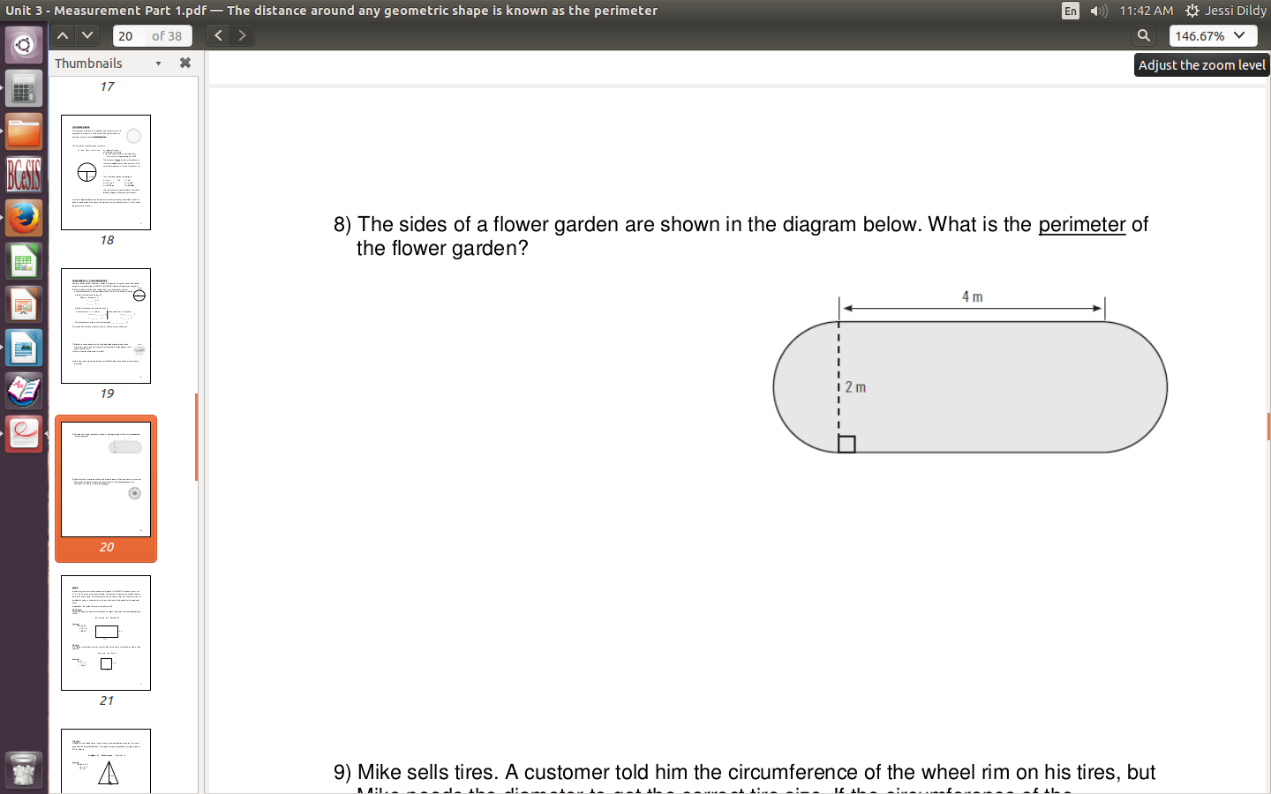
2. Find the perimeter

3. What is the thickness of the pipe?
Outer circumference: 120 mm
Inner circumference: 100 mm

