Chapter 2-3 Linear Measurement Name:
Calculations with Decimals and Fractions

Fractions
The imperial system is usually divided into fractions of an inch (eg. )
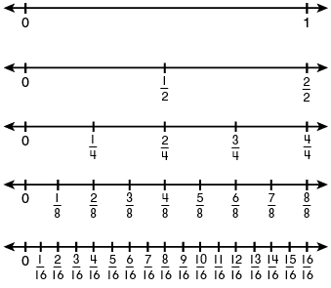
When comparing values it is useful to convert all fractions to a common denominator.

Multiply top and bottom by the same number (eg. ) This does not change the value of the fraction, only how is is represented, since .

Example: Arrange in order from smallest to biggest.

Adding and Subtracting Fractions

When adding and subtracting fractions you must first find equivalent fractions with a common denominator.

Example:

1.

2.

3.

Practice:
1.

2.

3.

Multiplying and Dividing Fractions

To multiply fractions it is as simple as multiplying numerator by numerator and denominator by denominator. Reduce the resultant fraction to lowest terms.

Example:

1.

2.

3.

To divide fractions take the inverse of the second fraction and multiply (keep, change, flip) Reduce the resultant fraction to lowest terms.

Example:

1.

2.

3.

Sometimes it is possible to reduce a fraction before performing a multiplication.

Example:

1.

2.

