Chapter 1: Earning an Income Name:
Lesson 2: Hourly Wage and Overtime

Keeping Track of Time & Hourly Wages
When an employee is paid an hourly wage, it is necessary to keep track of the hours they have worked in order that the gross pay is calculated correctly.
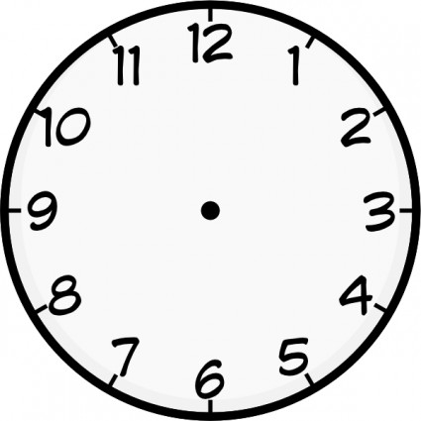
Everyone knows that an hour has 60 minutes. Therefore, parts of hours are based on the whole being 60 minutes as follows:

15 minutes  (quarter of an hour) | = 0.25
30 minutes  (half an hour) | = 0.5
45 minutes  (three quarters of an hour) | = 0.75

Practice: What decimal represents each of the following times?

a. 10 minutes

b. 20 minutes

c. 50 minutes

d. 75 minutes

e. 1 hour 30 minutes

f. 2 hours 45 minutes

An employee works from 8:30am to 2:30 pm. How many hours do they work?
(Subtract minutes and hours separately. A : is not a decimal )

Practice: How long did each employee work?

a. 9:00 am – 5:00 pm

b. 3:30 pm – 7:00 pm

c. 10:30 pm – 6:00 am

d. 8:30 am – 3:15 pm

Calculating gross income for employees paid an hourly wage is done by multiplying the wage by the number of hours worked as a decimal.

Example: Sherry works from 9:00 am to 2:30 pm and is paid $10.45 per hour. What are her earnings for a 5 day work week?

Shift Premiums
Employees who work less desirable shifts are often eligible for additional hourly pay called a shift premium. Shift premiums are often applied for weekend, overnight, or split shifts.

Example: Jim earns $11.20 per hour for regular shifts plus a shift premium of $1.20 per hour for working weekends. How much does he earn for working 7:00 am – 1:30 pm on Sunday?

Overtime
For most jobs regular time is considered 8 hours per day or 40 hours per week. Work done beyond regular time is considered overtime and is eligible for extra pay.

Time and a half: 1.5 times the regular wage for overtime hours
Double time: 2 times the regular wage for overtime hours

Example: Michelle earns $14.30 per hour plus time and a half for hours worked over 40 hours per week. Complete the chart and calculate her weekly gross pay:

Day | Start Time | End Time | Hours Worked
Monday | 8:30 am | 4:30 pm
Tuesday | 8:15 am | 4:45 pm
Wednesday | 8:30 am | 5:00 pm
Thursday | 8:00 am | 5:00 pm
Friday | 8:15 am | 4:45 pm
Total:
Regular Hours: Overtime Hours:

